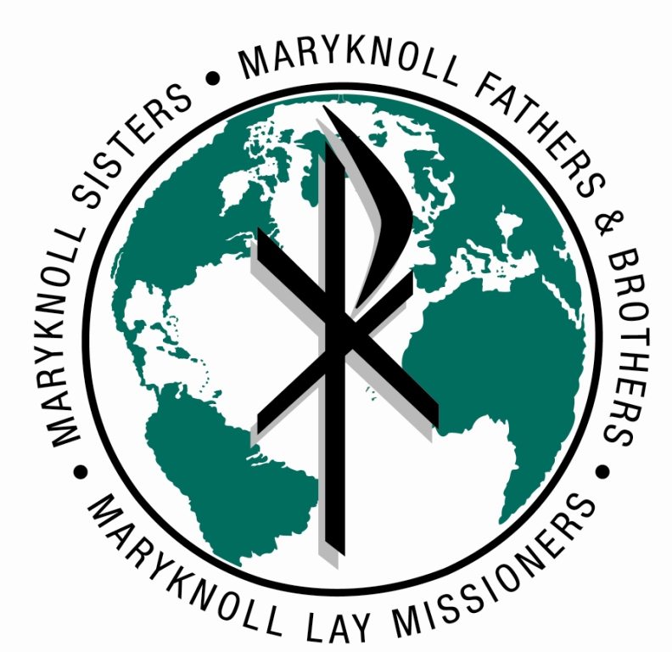
Maryknoll Office for Global Concerns
Peace, Social Justice and Integrity of Creation
www.maryknollogc.org

Sustainable Pathways to Peace & Security Program Internship
Focus: Central America

This intern will represent the Maryknoll Office for Global Concerns (MOGC) in working groups focusing on addressing the root causes of conflict and promoting nonviolent solutions to violence and systemic injustice in Honduras, Guatemala and El Salvador.

Objective:
• Keep MOGC actively involved with peace initiatives in Honduras, Guatemala and El Salvador through participation in working groups and coalitions
• Make visible MOGC support for diplomacy and peace-building strategies, and opposition to aggression and violence in Central America
• Inform MOGC constituents about peace efforts and the need for U.S. accountability in peace-building in communities in Honduras, Guatemala and El Salvador, through analysis posted on the website, in NewsNotes articles, action alerts, etc.

Work includes:
• Research and reporting on human rights, violence, peace and security, current political situations, drug trafficking, gang and youth violence in Honduras, Guatemala and El Salvador
• Coordinating with MOGC’s Faith-Economy-Ecology project on crossover issues
• Keeping MOGC staff informed about relevant campaigns and initiatives, including action alerts, sign-on letters, meetings and conferences
• Updating the MOGC website on information about Honduras, Guatemala and El Salvador
• Writing 2-3 700-word article for each bi-monthly issue of NewsNotes
• Writing action alerts for email and website distribution, as appropriate
• Maintaining communication with Maryknoll missioners in the Central America region
• Attending events and briefings on relevant issues
• Arranging Hill visits or other meetings with policymakers as appropriate

Requirements:

• Background and interest in Central America peace and justice issues
• Understanding of/respect for Maryknoll’s faith tradition
• Willingness to share office responsibilities
- Ability to work independently
• Spanish language skill is a plus but not required
• Available to work 15-25 hours/week
- Excellent spoken and written English

The ideal candidate will be available for one year, but we may consider shorter time periods. An hourly stipend is available for graduate/post-graduate students. Contact us for more information about our internships at ogc@maryknoll.org. To apply, please send your resume, a cover letter and short writing sample to aengelmann@maryknoll.org.

The Maryknoll Office for Global Concerns represents Maryknoll missioners, Catholic men and women who work with and serve people who are marginalized and impoverished around the world. The MOGC attempts to bring the concerns of the missioners and the people who they serve to the decision-making tables in the U.S. government, international financial institutions and the UN. We are active with a number of non-governmental coalitions, we publish a 20-page bimonthly newsletter, NewsNotes, and we maintain an urgent action network.

